**Remark**:

The labor cost didn’t take in account the crop like for maize and for soybean. Same with inputs according to the survey.

**Focus crop**: The “none of them” should not be chosen with the specified crops at the same time. fortunately, it seems like the “none of them” is not link to other questions. By the way, if we need the variable “focus crop later, then it has to be cleaned.

-----------

I updated the variables

I’m missing f_othermaincrop_1_price and f_othermaincrop_2_price

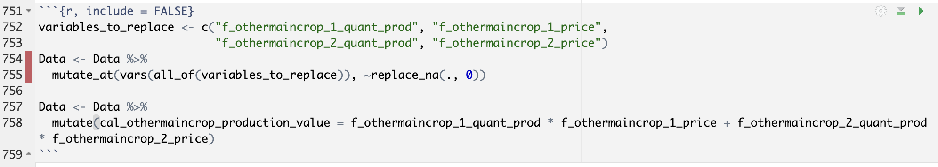

But we do have the f_othermaincrop_1_inc_sold and f_othermaincrop_2_inc_sold. Does this calculation make sens?

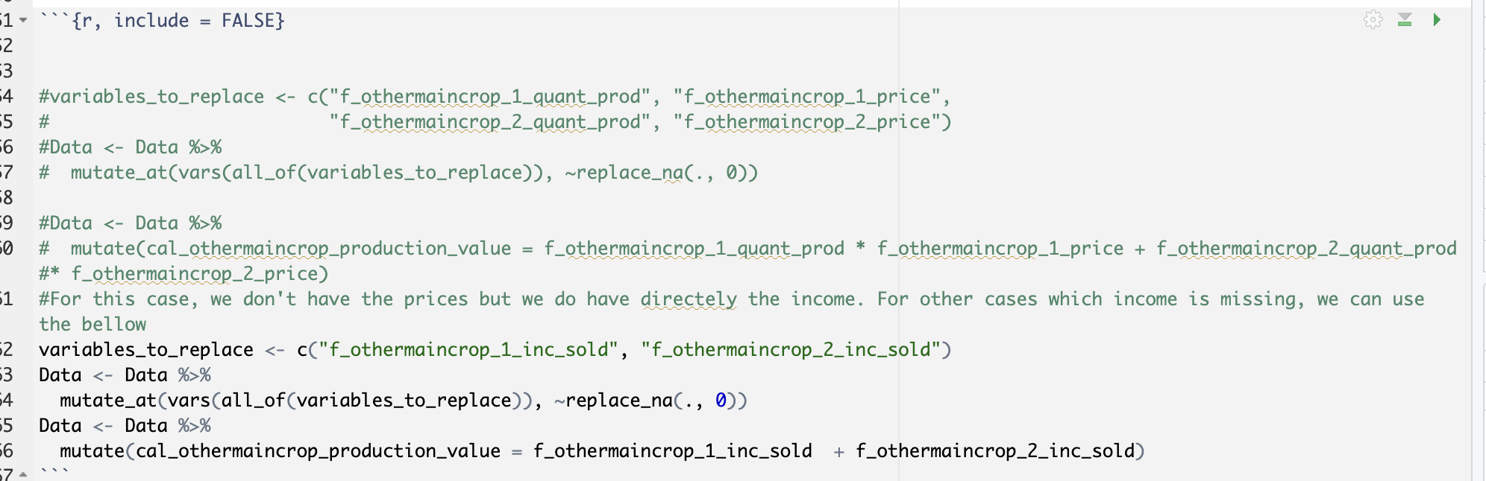

Missing f_livestock_nr_hired_labourers`, `f_livestock_days_hiredlabour`, `f_livestock_wages_hiredlabour`, and `f_livestock_costs_other`

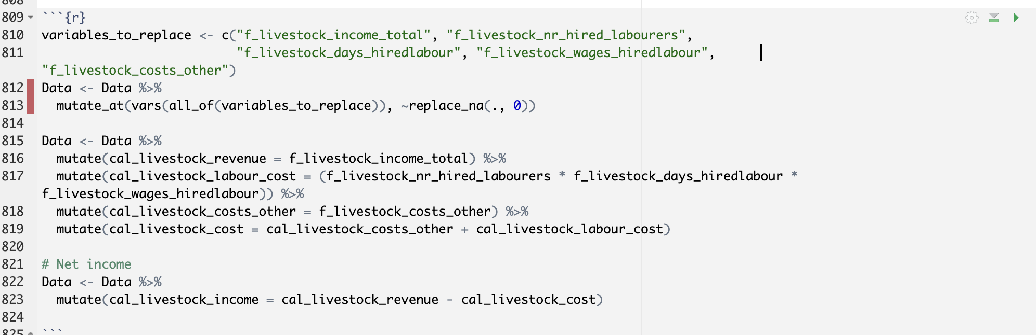

`hh_loan_one_size`, `hh_loan_one_value_interest`, `hh_loan_two_size`, and `hh_loan_two_value_interest`

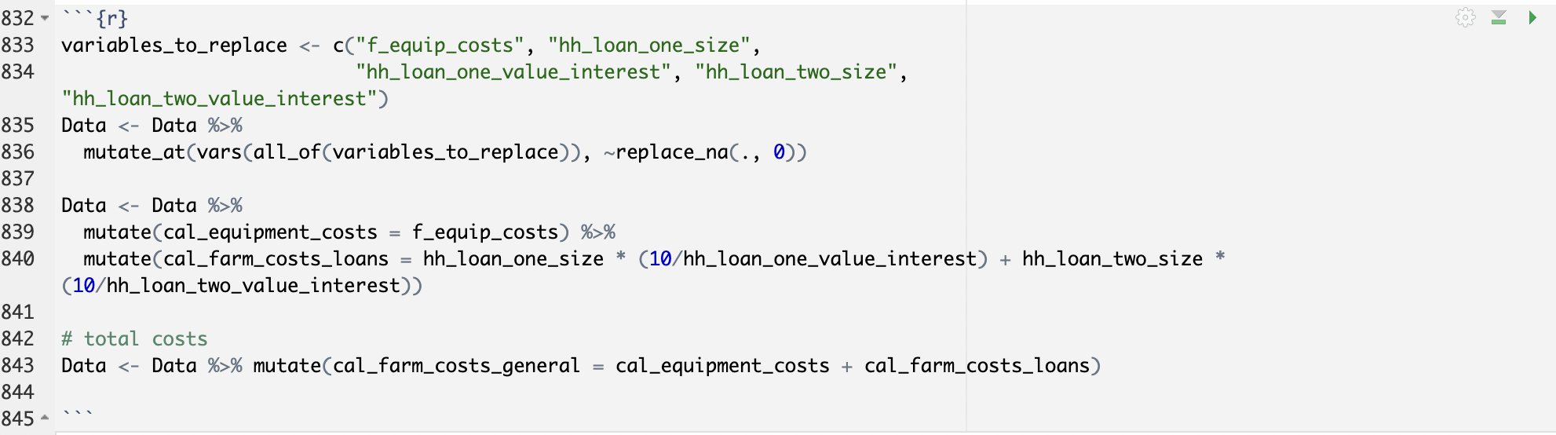

Missing f_income_other_month

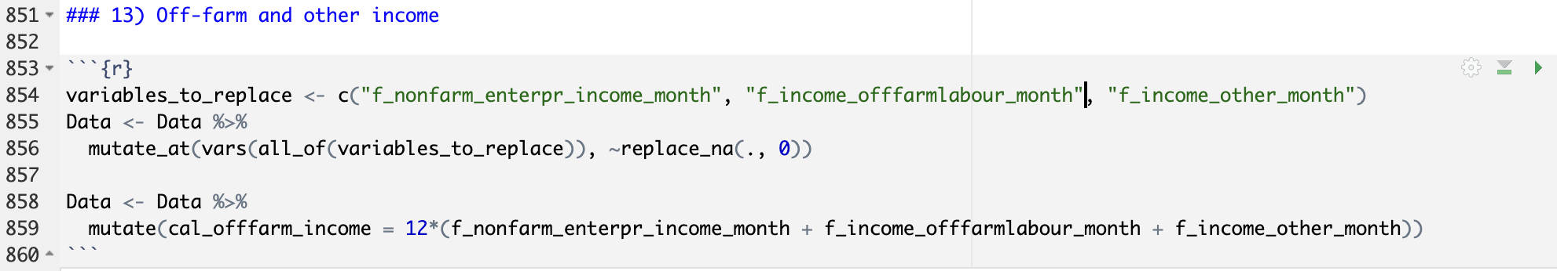

I adapted the variables. But I need to understand the purpose of replacing values with f_livestock_income_share values. Or maybe an error?

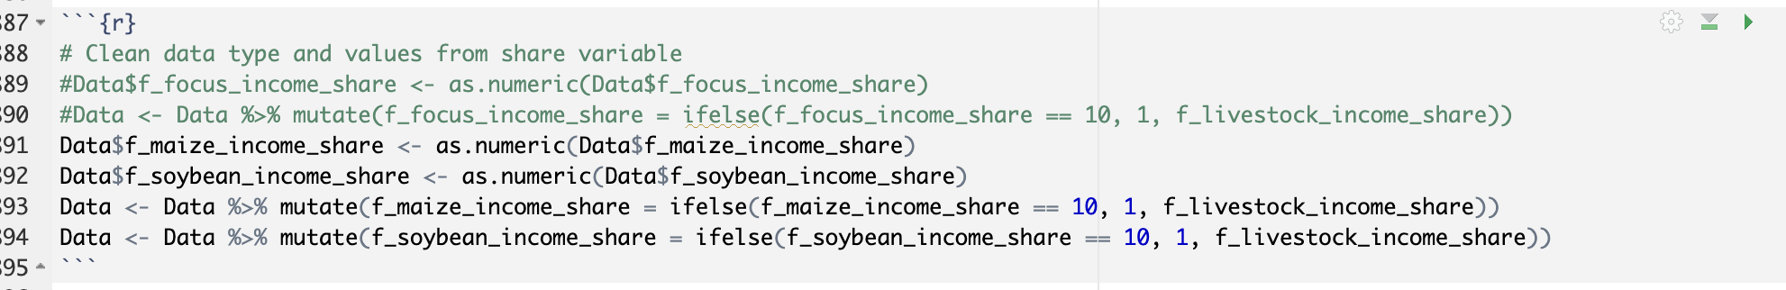

Updated this

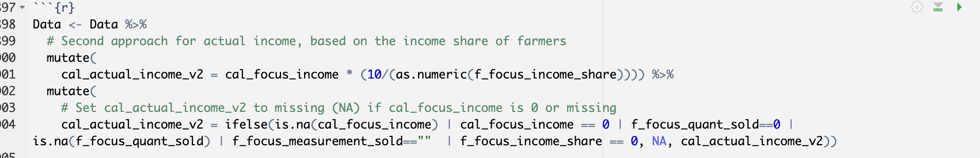

Into this

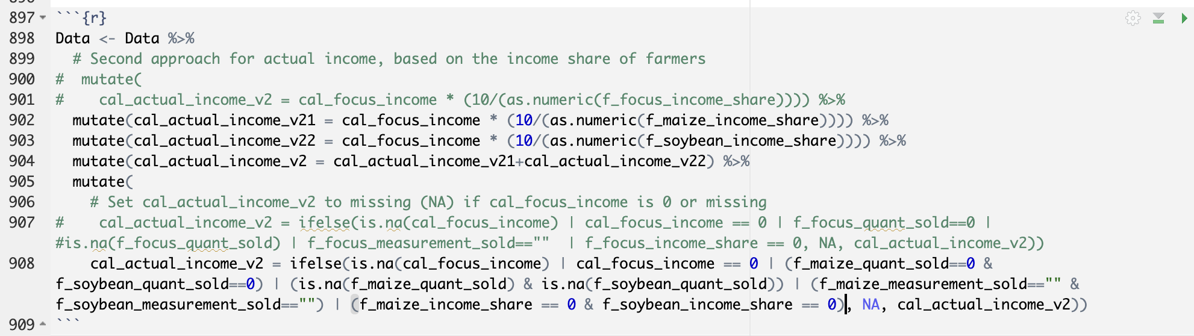

Based on my understanding. I made two actual income before making addition

*Remarque*: The Net income is mostly negative. Let’s check the calculation of the revenue if well defined, just to be sure

Doesn’t work

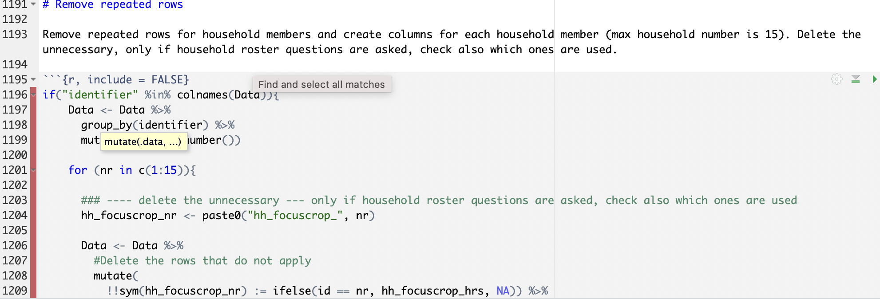

Are we in baseline or endline

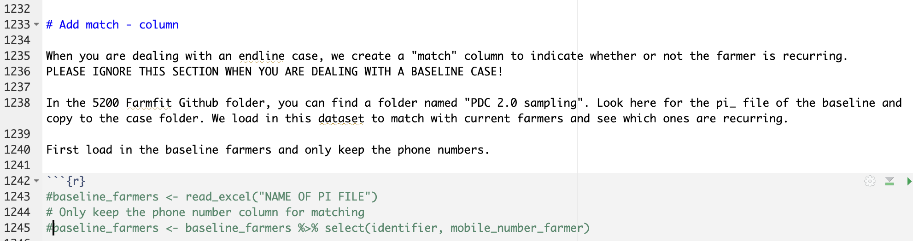

I need to understand this. How to do the comparison?

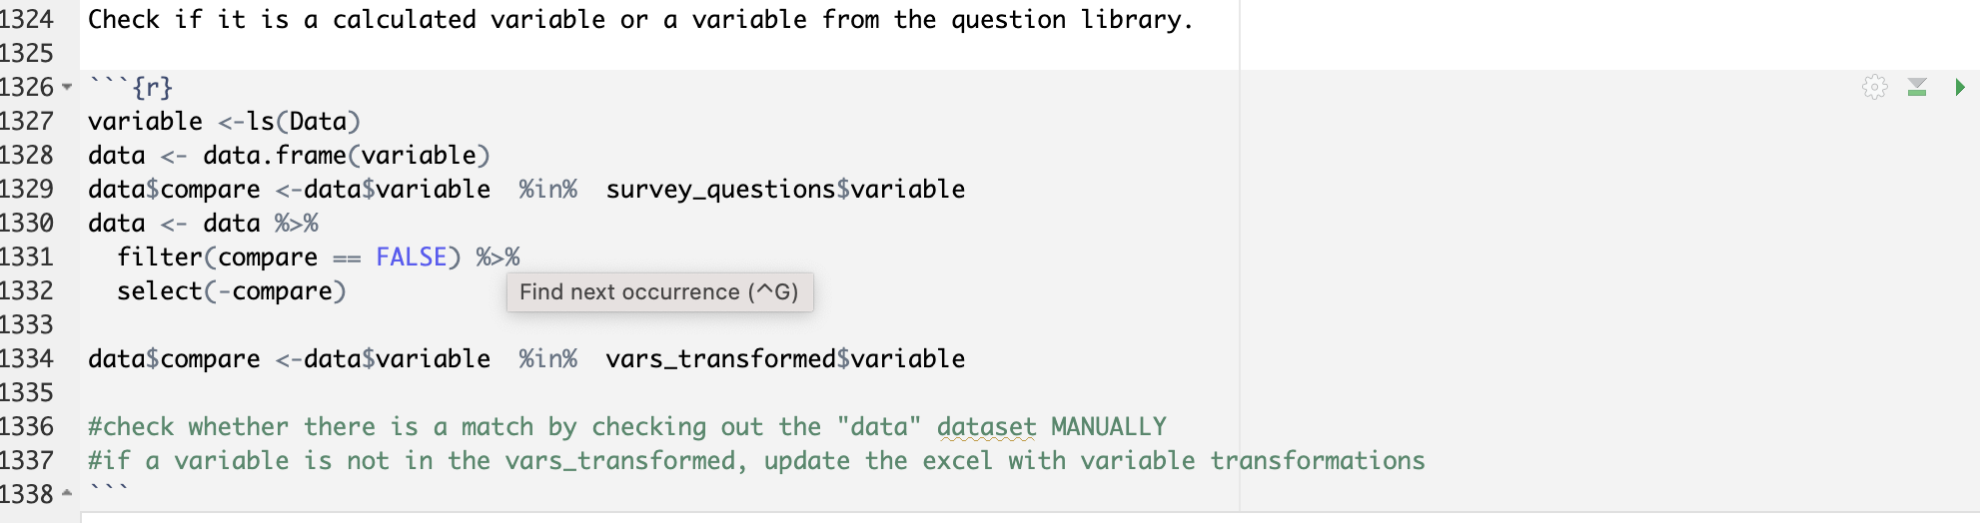

What’s the purpose? The result doesn’t make sens



ek6h-6qtt-4pu0 , fa4d-9uph-0k4k

line to be delated

calculated with total revenue (maize+soy) because we don’t have the cost per crop

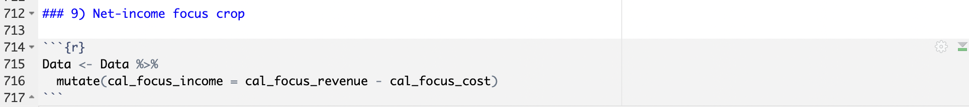

Not calculated:

* cal_othermaincrop_production_value
* cal_farm_costs_loans
* cal_livestock_labour_cost
* cal_livestock_costs_other
* cal_livestock_cost
* cal_livestock_income = cal_livestock_revenue - cal_livestock_cost: missing cal_livestock_cost so calculate without it. cal_livestock_income = cal_livestock_revenue
* cal_farm_costs_loans not calculated: then cal_farm_costs_general = cal_equipment_costs
* f_income_other_month missing, so cal_offfarm_income = 12*(f_nonfarm_enterpr_income_month + f_income_offfarmlabour_month
* leave out: Second approach for actual income, based on the income share of farmers
* Remove repeated rows: code doesn’t work and fortunately the date doesn’t have duplicates